Introduction to Networks

Task 1 :- Draw a simple diagram (hand-drawn or digital) showing how your phone connects to Instagram, including your device, WiFi router, ISP, and Instagram server. Label each part and the connections.

ANS :-
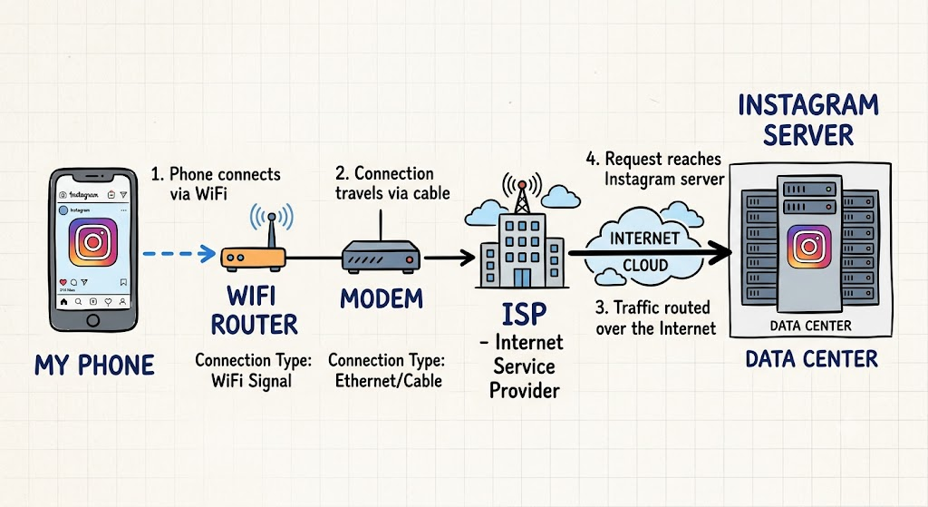
.

Task 2 :- List 5 devices you use or see daily that are part of a network (for example: smartphone, smart TV, WiFi router, laptop, smartwatch). For each, write what type of network it connects to (LAN, WAN, PAN, etc.).

ANS :-

PAN: Personal Area Network
LAN: Local Area Network
WAN: Wide Area Network

- Smartphone :
Connects to PAN (Bluetooth/wireless earbuds) and LAN (home Wi-Fi).

- Smart TV :
Connects to LAN (home Wi-Fi / Ethernet cable).

- Smartwatch :
Connects to PAN (Bluetooth directly to phone).

- Laptop :
Connects to LAN (home/office Wi-Fi).

- Wi-Fi Router :
Connects to WAN (links home network to internet).

Task 3 :- Explain the difference between the Internet and an intranet using an example from your college or a public WiFi you have used.

ANS :-

Internet | Intranet
It is public. | It is private.
The global, wide-open network anyone can access. | A restricted, local network only meant for specific members.
Example: Browsing YouTube or Instagram on a café's public Wi-Fi. | Example: Logging into your college portal (like submitting assignments/viewing grades) that only works when connected to campus Wi-Fi or with student logins.

Task 4 :- Pick any one app you use (like WhatsApp, Zomato, or Flipkart) and describe, in 4-5 lines, how data travels from your device to their server and back when you perform a search inside the app.

ANS :-

1.Your Phone : You type a name, and your phone sends that search as a quick digital request.
2.Wi-Fi Router: Your phone sends the request through the air to your Wi-Fi router.
3.ISP Network : The router pushes the message through your Internet provider's cables across the web.
4.WhatsApp Server : The server finds your match and sends the results straight back down the same path to your phone screen in milliseconds.

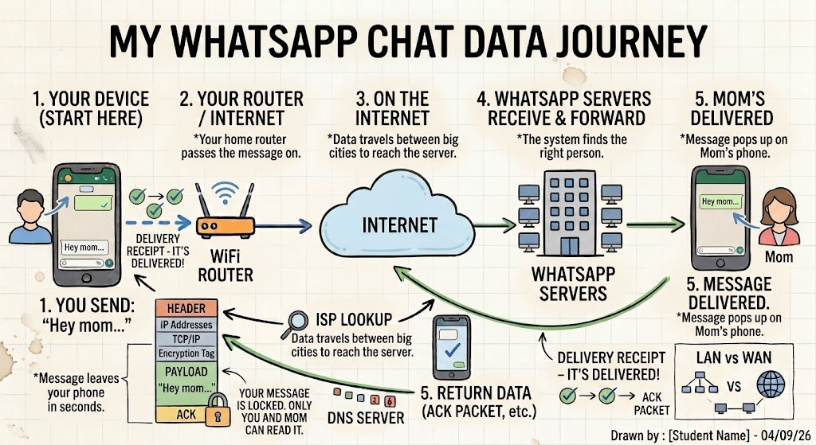
*For example here is diagram :-

